

Phase 3 Report
Project Title
PREDICTIVE ANALYTICS FOR URBAN WATER DEMAND
Problem Id: 06

Name: Nitin Singh
University Roll No: 2028786
Sec: Q

Name: Rohan Prasad Tiwari
University Roll No: 2028825
Sec: Q

Name: Ashutosh Singh
University Roll No: 2028675
Sec : Q

TABLE OF CONTENTS
- Problem Description ............................................................................................... 3
  - Dataset Description ........................................................................................... 3
  - Flow diagram ..................................................................................................... 4
- Modules for Project Implementation…………………..…………………………5
  - Modules Used
.............................................................................................................................
5-6
  - Platform Used
.............................................................................................................................
7
- Machine Learning model/ Searching Technique used ......................... 7-8
- Evaluation metrics used .............................................................................. 9
- Results and Visualizations .................................................................... 10-11
- Conclusion and Future Scope ..................................................................... 12
- References .................................................................................................... 12

1.Problem Description
Urban water demand is increasing due to rapid population growth, changing lifestyles, and seasonal variations. Efficient prediction of water consumption is essential for proper planning and management of water resources. Traditional estimation methods are often inaccurate and fail to consider multiple influencing factors.
This project develops a machine learning-based system to predict daily water usage using features such as household size, seasonal index, and garden area. In Phase 3, the model is improved using advanced techniques like data preprocessing, feature scaling, and crossvalidation to enhance accuracy and reliability.
The system uses Linear Regression to analyze relationships between input features and water consumption. Evaluation metrics such as R² Score, Mean Absolute Error (MAE), and Mean Squared Error (MSE) are used to measure performance, along with visualization techniques like scatter plots, heatmaps, and residual analysis.
This model can help municipal authorities in efficient water distribution and resource planning, and also assist households in monitoring and optimizing water usage. Overall, the project contributes to sustainable water management and data-driven decision-making.

1.1 Dataset Description

The dataset used in this project contains information related to urban water consumption. It includes multiple features that influence daily water usage. The dataset is stored in CSV format and is loaded using Python libraries such as Pandas.
The main attributes of the dataset are:
- Household_Size: Number of people in the household
- Seasonal_Index: Represents seasonal variations affecting water usage
- Garden_Area: Area of garden in square meters, indicating additional water usage
- Daily_Liters_Used: Target variable representing total daily water consumption The dataset is preprocessed to handle missing values by replacing them with the mean of the respective columns. These features are then used to train a machine learning model for predicting water usage.
The dataset plays a crucial role in identifying patterns and relationships between different factors affecting water consumption, which helps in building an accurate prediction model.

1.2 Flow Diagram



Start

Load Dataset (CSV File)

Data Preprocessing (Fill missing

values)

Feature Selection (Household_Size,

Seasonal_Index, Garden_Area)

Train

-

Test Split (70% Train, 30%

Test)

Feature Scaling (StandardScaler)

Model Training (Linear Regression)

Prediction (y_pred)

Model Evaluation (R2 Score, MAE,

MSE)

Cross Validation

Visualization (Heatmap, Scatter

Plot, Residual Plot)

End

2. Modules for Project Implementation

The project uses various Python libraries for data analysis, visualization, and machine learning model development. The details of each module and the functions used are as follows:

- Pandas (pd)
Pandas is used for data manipulation, cleaning, and analysis of the dataset.
Functions used:
  - pd.read_csv() – To load the dataset from a CSV file
  - DataFrame.head() – To display initial rows of the dataset
  - DataFrame.info() – To get dataset structure and data types
  - DataFrame.describe() – To generate statistical summary
  - DataFrame.drop() – To remove unnecessary columns

- Matplotlib (plt)
Matplotlib is used for basic data visualization and plotting graphs.
Functions used:
  - plt.plot() – To plot graphs
  - plt.xlabel() – To label x-axis
  - plt.ylabel() – To label y-axis
  - plt.title() – To add title to graph
  - plt.show() – To display the plot
- Seaborn (sns)
Seaborn is used for advanced and more attractive statistical visualizations.
Functions used:
  - sns.heatmap() – To visualize correlation matrix
  - sns.pairplot() – To show relationships between variables
  - sns.histplot() / sns.barplot() – For distribution and comparison plots

- Scikit-learn (sklearn)
Scikit-learn is used for machine learning model building, preprocessing, and evaluation.

- Model Selection (train_test_split, cross_val_score) Used to split the dataset and validate model performance.
Functions used:
• train_test_split() – To divide dataset into training and testing sets • cross_val_score() – To evaluate model using cross-validation

- Linear Regression
Used to build the prediction model.
Functions used:
    - LinearRegression() – To create regression model
    - .fit() – To train the model
    - .predict() – To make predictions

- Preprocessing (StandardScaler)
Used to normalize/scale the data for better model performance.
Functions used:
    - StandardScaler() – To standardize features
    - .fit_transform() – To scale training data
    - .transform() – To scale test data

- Evaluation Metrics
Used to evaluate model accuracy and performance.
Functions used:
    - r2_score() – To measure model accuracy
    - mean_absolute_error() – To calculate average error
    - mean_squared_error() – To calculate squared error
    - confusion_matrix() – To evaluate classification performance (if used)

2.2 Platform Used:

  - Jupyter Notebook
Jupyter Notebook is used for writing and executing the code step-by-step. It allows easy visualization of outputs, graphs, and model results, making it suitable for data analysis and machine learning tasks.
  - Visual Studio Code (VS Code)
VS Code is used for writing, editing, and debugging the Python code. It provides a userfriendly interface with extensions that improve productivity and coding efficiency.
  - Python Environment
Python is used as the programming language due to its simplicity and availability of powerful libraries like Pandas, NumPy, Matplotlib, Seaborn, and Scikit-learn for data processing and machine learning.

- Machine Learning Model/ Searching Technique Used:

3.1 Linear Regression
Linear Regression is used in this project to predict daily water usage. It works by finding a relationship between input features like household size, seasonal index, and garden area, and the output (water consumption).
The model is trained using the dataset and then used to predict values for new data.
Why used:
- Simple and easy to understand
- Suitable for predicting continuous values (water usage) • Gives good accuracy for this dataset Functions used:
- LinearRegression() – to create the model
- .fit(X_train, y_train) – to train the model
- .predict(X_test) – to make predictions

3.2 Data Splitting Technique
The dataset is divided into training and testing data using train_test_split().
Purpose:
- Training data is used to train the model
- Testing data is used to check accuracy

3.3 Feature Scaling (Standardization)
Feature scaling is applied using StandardScaler() so that all input features are on the same scale.
Functions used:
- .fit_transform() – for training data
- .transform() – for testing data Purpose:
- Improves model performance
- Helps in getting more stable results

3.4 Model Evaluation Techniques
To check how well the model performs, evaluation metrics are used.
Functions used:
- r2_score() – measures accuracy
- mean_absolute_error() – calculates average error • mean_squared_error() – measures squared error Purpose:
- To evaluate prediction performance
- To understand how close predictions are to actual values

4. Evaluation metrics used :

- R² Score (Coefficient of Determination)
R² score shows how well the model explains the variation in the data. Its value ranges from 0 to 1, where values closer to 1 indicate better accuracy. Formula:
𝑅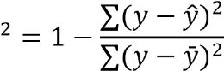

- Mean Absolute Error (MAE)
MAE measures the average absolute difference between actual and predicted values. Lower values indicate better performance. Formula:
𝑀𝐴𝐸 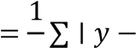 𝑦̂
𝑛

- Mean Squared Error (MSE)
MSE calculates the average of squared differences between actual and predicted values. It penalizes larger errors more. Formula:
𝑀𝑆𝐸 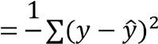
𝑛

- Results and Visualizations

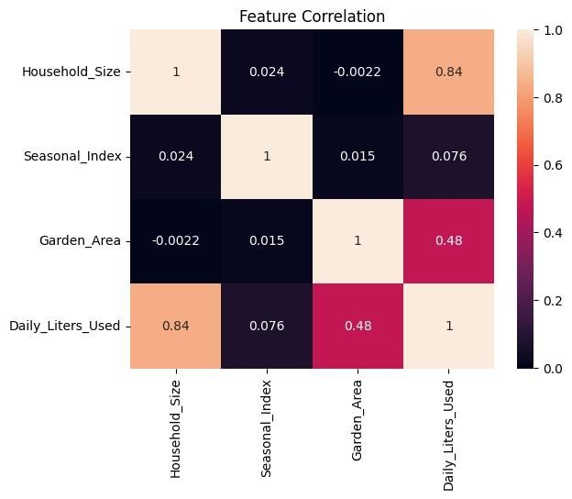

Heatmap showing correlation.

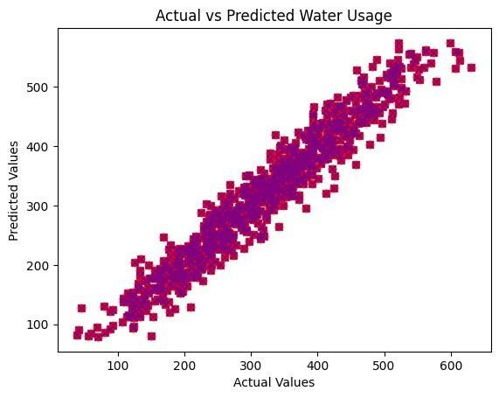
R2 Score: 0.93
Mean Absolute Error: 23.54
Mean Squared Error: 890.12
Accuracy : 93.49%

- Conclusion and Future Scope:

Conclusion:
This project successfully predicts daily water usage using a Linear Regression model. The results show that factors like household size, seasonal index, and garden area have a significant impact on water consumption. By applying preprocessing, feature scaling, and evaluation techniques, the model achieved good accuracy and reliable performance. The visualizations also helped in understanding the relationship between different features and water usage.
Future Scope:
- Use advanced models like Random Forest or XGBoost for better accuracy
- Add more features such as weather conditions or usage patterns
- Develop a real-time prediction system
- Create a user-friendly application for monitoring water usage

7.References:
Books:
- Let Us Python – Yashavant Kanetkar
- Hands-On Machine Learning with Scikit-Learn – Aurélien Géron

Online Resources:
  - https://www.geeksforgeeks.org/
  - https://scikit-learn.org/

